Custom CNC Machined Shift Knob
During the Spring semester of my junior year in college, I had the opportunity to take a machine shop class, something I’d been wanting to do for years. Over the course of the semester, we learned how use a wide range of tools including lathes, mills, as well as MIG (GMAW) and TIG (GTAW) welders. While I had used most of these before, I had never had the chance to use a CNC mill or lathe (aside from a CNC router). So, when assigned a final project of our own personal choosing, I jumped at the opportunity of having free reign over these machines.
We were only allotted three class sessions to work on our projects, so I couldn’t create anything too fancy or with many parts. We were also required to use three or more processes to make it (mill, lathe, waterjet, welding, etc.). Ultimately, I decided to make a shift knob for my car thinking it would be quick and easily doable in three class sessions (I was wrong). In the end, I spent 20-ish hours in the machine shop making friends with the staff and asking them for help on my project.

Custom Shift Knob CAD Model
Despite asking for help, I did not want any hand-holding. I would ask for as little information as possible, just enough to not crash a big and expensive CNC machine. There are two machinists, each with decades of experience each, who were happy to share their expertise with me. While I know I could do it again, it was very tough to wrap my head around the setup the first time – how and where to mount the lathe tools, what order of operations is best, you name it! I greatly appreciate the advice they gave me.
[Insert ‘CAM Path.mp4’ here]
Computer-Aided Manufacturing (CAM) Simulation
I eventually settled on a process that worked out well. I cut aluminum bar stock to length on a band saw. Then I chucked it up in the Haas TL-2 CNC lathe and ran my program, but not before mounting and setting the zero on all of my tools and the stock itself. I made sure to leave the shift ball attached to the stock so that it could be easily mounted in a milling vice or back in the lathe for future operations. After that, I drilled and tapped 6 evenly spaced holes radially around the top of the shift knob. I then cut another piece of stock to be used as the top plate on the band saw. We didn’t have aluminum sheet of the proper thickness so I used a smaller piece of bar stock. I put it in the manual Bridgeport mill and drilled the corresponding mounting pattern in it. Then I mounted the stock in a lathe to cut to the right diameter and then parted off the plate, ensuring to check that it was within tolerance from my CAD model and corresponding drawing. I then mounted the plate on top of the shift knob using six M2.5 machine screws, and mounted the whole assembly in the CNC mill. After zeroing off the part and tools with a probe, I ran a program to engrave the shift pattern into the decorative top plate. Lastly, I mounted the shift knob back in the lathe using the stock I had left, and then brushed it with a scotch-brite pad before parting it off.
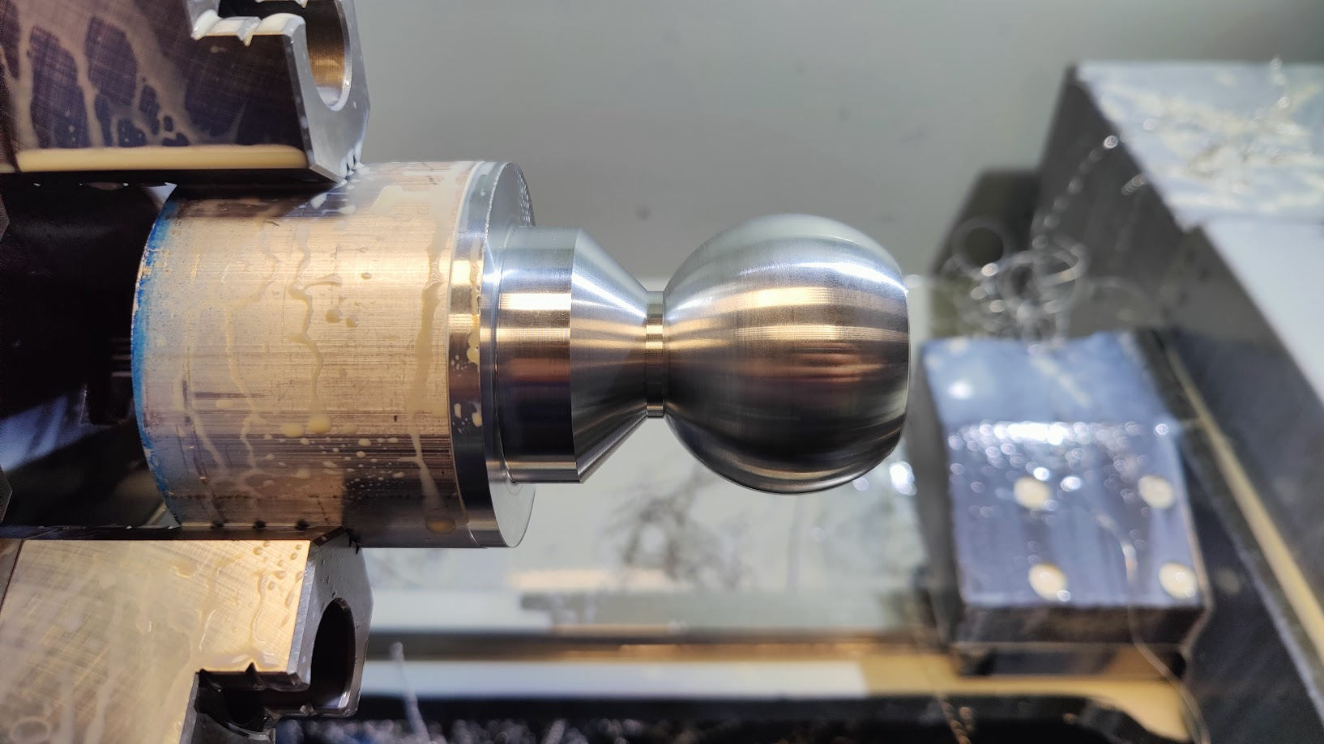
In-Progress Shot of Shift Knob on the Lathe
I was - and still am - thrilled with the end result. One small issue that I failed to consider until I had already started the project is that the knob gets too hot to touch after having sat outside in the phoenix heat. It’s a shame that I have to keep a microfiber cloth on it just to be able to use it, but come wintertime, it’ll be a show stopper!
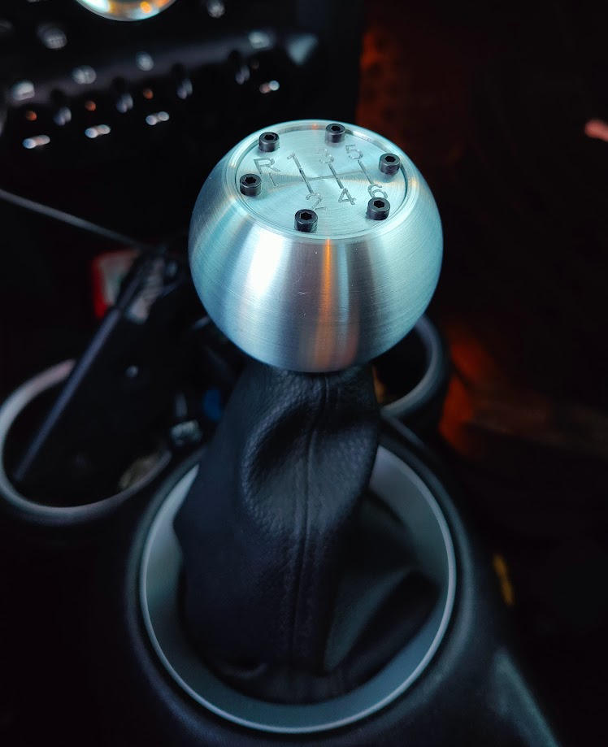
Shift Knob Installed in my Car

